Chapter 17, Solution 23.

Using Fig. 17.61, design a problem to help other students to better understand finding the Fourier series of a periodic wave shape.

Although there are many ways to solve this problem, this is an example based on the same kind of problem asked in the third edition.

Problem

Find the Fourier series of the function shown in Fig. 17.61.

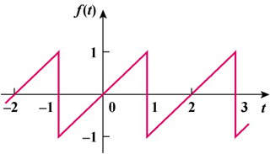

Figure 17.61

Solution

f(t) is an odd function.

f(t) = t, −1< t < 1

a_{o} = 0 = a_{n}, T = 2, ω_{o} = 2π/T = π

b_{n} = 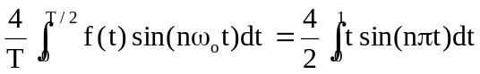

= 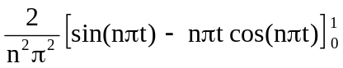

= −[2/(nπ)]cos(nπ) = 2(−1)^{n+1}/(nπ)

f(t) = 